Milan SCD Course 2 in preparazione per il Fife Reelers Ball (2/4/22)

Date | No. | Ripasso | Ripasso | New dance 1 | New dance 2
Course 2
2021
29/11 | 1 |  | Hoopers Jig | Polharrow Burn
13/12 | 2 |  | Gang the Same Gate | Montgomery's Rant
20/12 | 3 |  | JB Milne | Bees of Maggieknockater
2022
24/1 | 4 | Hoopers Jig | Montgomery's Rant | Irish Rover
31/1 | 5 | Gang the Same Gate | Polharrow Burn | Highland Welcome
7/2 | 6 | JB Milne | Bees of Maggieknockater
14/2 | 7 | Makin’ the Tartan | Ian Powrie's Farewell to Auchterarder
21/2 | 8 | Shiftin’ Bobbins | Ian Powrie | Napiers Index | Peat Fire Flame
28/2 | 9 | Duke of Perth | Ian Powrie | Cherrybank Gardens | Water of Leith
7/3 | 10 | Ripasso di tutte le danze nuove
Course 3
14/3 | 1
21/3 | 2 | John’s b/day
28/3 | 3 |  | Ripasso x FRB | (se andiamo)
2/4 | 4 | Fife Reelers Ball?
4/4 | 5
11/4 | 6
18-25/4 |  | Pasquetta/Liberazione
2/5 | 7
9/5 | 8
16/5 | 9
23/5 | 10
28/5 |  | 3rd Milan Highland Ball?
Course 4
30/5 | 1
6/6 | 2
13/6 | 3
20/6 | 4
27/6 | 5
4/7 | 6
11/7 | 7
25/7 | 8

A Highland Welcome (Forbes)
Bill Forbes Craigievar Book 1 (Music: Loch Leven Castle or The Sailor)
Reel n x 32 bars 2 Couple Repeat 2 Couple Set Progressive Round the Room Set
1s face 2s around the room, 1s going clockwise, 2s anticlockwise.
1-8 All 4 hands round and back;
9-16 all 4 hands across and back;
17-20 1M2L 1L2M turn by the left, finishing facing partners;
21-24 1s 2s turn by the right;
25-28 1s 2s advance and retire;
29-32 1s 2s advance, 1s pass under the arch made by 2s and continue to meet the next couple.

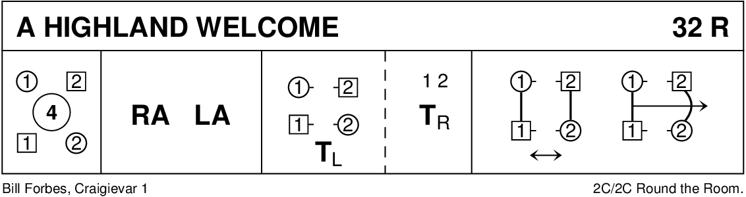
Hooper's Jig
Anon 99 More Scottish Country Dances (Music: original)
Jig 8 x 32 bars 3 Couple Repeat 4 Couple Set Longwise Set
1-4 All clap, 1s cross (giving right shoulder, no hands) and cast;
5-8 1s3s right hands across;
9-12 all clap, 1s cross (giving right shoulder, no hands) and cast up;
13-16 1s2s left hands across;
17-18 1M3L cross diagonally by the right;
19-20 1L3M cross diagonally by the right;
21-22 1M3L cross diagonally by the right;
23-24 1M cast WHILE 2s step up WHILE 1L3M cross diagonally by the left, 1L finishing in 2nd place;
25-32 2s1s rights and lefts.

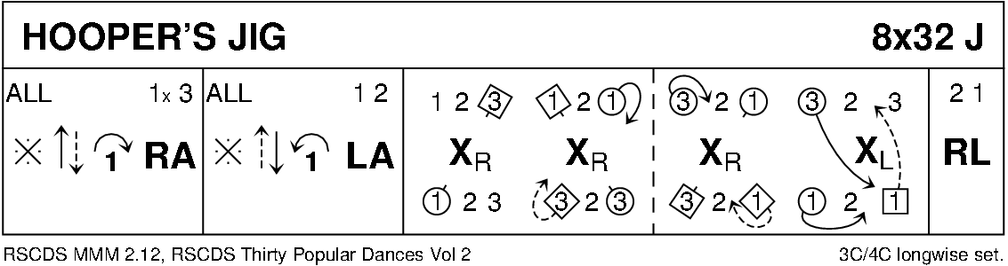

Polharrow Burn (Music: Original or Stirling at 90)
Hugh Foss Glendarroch Scottish Dance Sheets
Reel 5 x 32 bars 5 Couple Repeat 5 Couple Set Longwise Set
1-4 1s 3s cross by the right and cast;
5-8 1s 3s half figures of 8 round 2s 4s;
9-12 1s 3s turn by the right WHILE 2s and 5s cross by the right and chase clockwise round the set;
13-16 1s 3s turn by the left WHILE 2s and 5s continue to chase clockwise round the set (finishing 5s at top, 2s at bottom);
17-20 1s 3s half diagonal reels of 4 with first corner positions;
21-24 1s 3s repeat with second corner positions;
25-28 1s 3s repeat with partners' first corner positions;
29-32 1s 3s turn by the left and cast, finishing 2s4s1s5s3s.

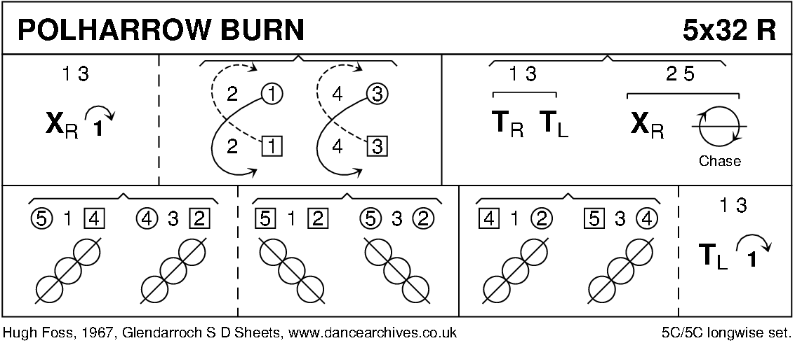
Gang the Same Gate
Milton Levy RSCDS Book 36 (Music: original or The Lea Rig or Miss Shearer’s Strathspey)
Strathspey 8 x 32 bars 3 Couple Repeat 4 Couple Set Longwise Set
1-2 1s cross by the right;
3-4 1s cast 2 places WHILE 2s3s step up;
5-6 1s meet below 3s and cross by the right;
7-8 1s cast up to 2nd place WHILE 3s step down;
9-10 1s set advancing and pass to face first corners;
11-12 1s turn first corners with both hands and finish facing second corners;
13-16 1s half reel of 4 with second corners, finishing with petronella turn, 1M at the top facing down, 1L at the bottom facing up;
17-18 1s set advancing and pass to face second corners;
19-20 1s turn second corners with both hands and finish facing first corners;
21-24 1s half reel of 4 with first corners, finishing with petronella turn to 2nd place on opposite sides;
25-32 set and link for 3:
25-26 all set on the sides;
27-28 3L 2M (at the left end of each line) dance (passing left shoulders) to the other end of the same line WHILE the others cast to the right one quarter round the square, finishing 2L1L2M facing down, 3L1M3M facing up;
29-32 repeat bars 25-28 in lines across the set, finishing 2s1s3s.
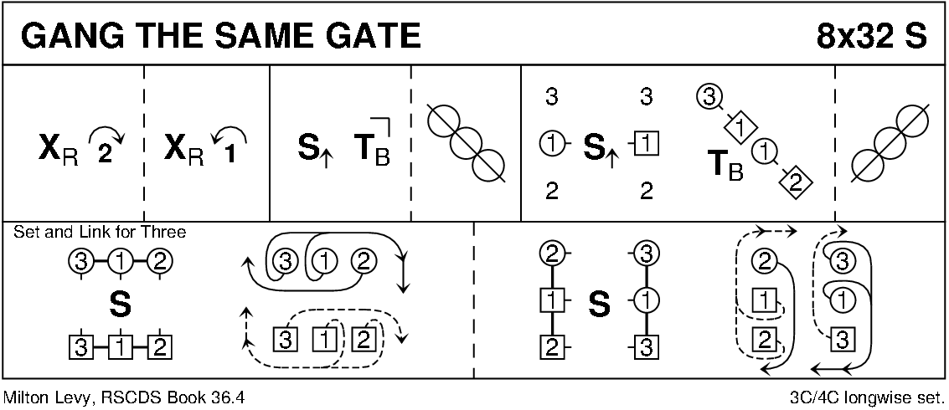
The Montgomeries' Rant
Castle Menzies Mss RSCDS Book 10 (Music: original)
Reel 8 x 32 bars 3 Couple Repeat 4 Couple Set Longwise Set
1-4 1s cross by the right and cast;
5-8 1s cross by the left and cast (1L up, 1M down);
9-16 1L2s 1M3s reels of 3 across, 1s finish facing 2L;
17-18 1s set to 2L and turn about to face 3M;
19-20 1s set to 3M and turn ¼ anticlockwise (1M dancing backwards) to face 3L;
21-22 1s set to 3L and turn about to face 2M;
23-24 1s set to 2M, finishing 1M facing up, 1L down;
25-30 1L2M3M, 1M2L3L reels of 3 on opposite sides (right shoulder to second corners to start);
31-32 1s cross to 2nd place.

Notes
3-4 2s step up.
17-18 1s turn about toward each other.
21-22 1s turn about toward each other.
31-32 While not authentic, crossing by the left fits better, especially in the 2nd, 4th and 6th repeats when it can be changed to cross down WHILE 3s (in 4th place of the full set) step up.

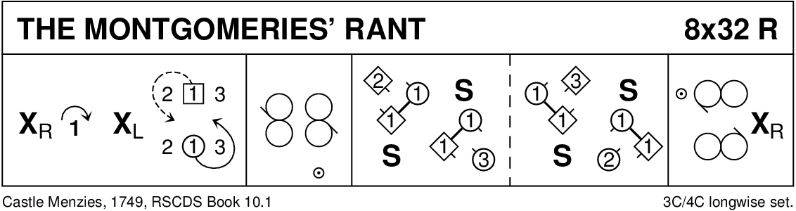

J.B. Milne
Hugh Foss Angus Fitchett Album (music: original)
Reel 8 x 32 bars 3 Couple Repeat 4 Couple Set Longwise Set
1-4 1M2L set advancing and turn by the right;
5-8 1L2M set advancing and turn by the right;
9-12 1s set advancing and turn both hands;
13-16 1s cast & petronella turn finishing 1L at top facing down and 1M at bottom facing up;
17-20 1s set and turn by the right ¾ to opposite sides WHILE 2M3M 2L3L cross by the right on the sides and set;
21-24 1s set and turn by the right ¾ (finishing 1M at top facing down and 1L at bottom facing up) WHILE 3s 2s cross by the right and set;
25-28 1s set and cross (up and down) by the right WHILE 3L2L 3M2M cross by the right on the sides and set;
29-30 1s cast (L down, M up) to 2nd place on own sides WHILE 2s 3s cross by the right, all finishing facing in;
30-32 2s1s3s set on the sides.

NB 1-12 Pas-de-basque throughout.

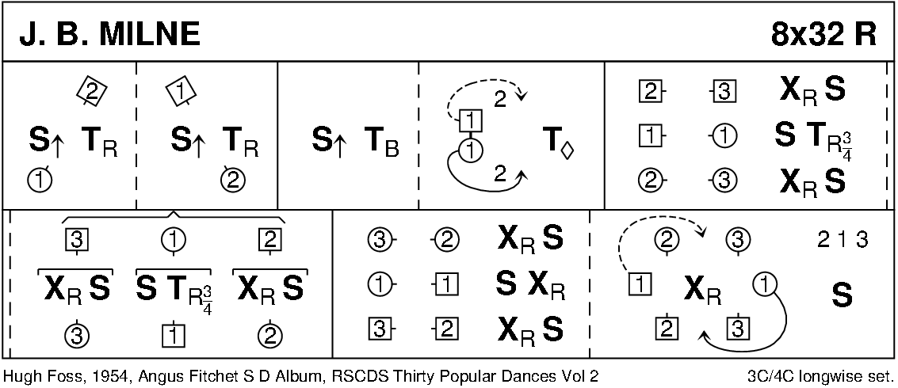
The Bees of Maggieknockater
John Drewry Canadian Book (Music: original)
Jig 4 x 32 bars 4 Couple Repeat 4 Couple Set Longwise Set
1-4 1s cross and cast;
5-8 1s3s right hands across;
9-12 1M3L (promenade hold) half reel of 3 on Ls' side WHILE 1L3M half reel of 3 on Men's side (both going to the right and giving right shoulder);
13-16 repeat with own partners (going to the left and giving left shoulder);
17-24 repeat bars 9-16 on opposite sides, finishing with 3s in 2nd place, 1s facing down between them;
25-28 1L3M turn by the right WHILE 1M3L turn by the left, 1s crossing down to finish between 4s;
29-32 1L4L turn by the left 1¼ times WHILE 1M4M turn by the right 1¼ times, finishing 2s3s4s1s.

NB 9-24 Right with the "wrong partner", left with the right one is a good mnemonic when about to promenade out through the sides.
1M dance clockwise around the whole set starting around 4L's position.
1L dance anticlockwise around the whole set starting around 1M's position.
Half reels with a promenading "couple" are difficult to make neat; corners must be especially helpful.
Covering should be diagonally and so hands should not be taken.
-28 Even if not actually in the sidelines, 3s must leave enough room for 1s to finish between them.

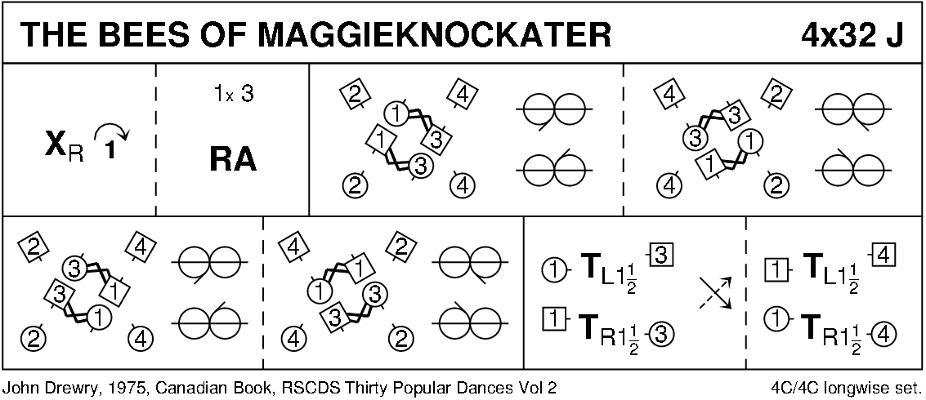
THE WATER OF LEITH (S4x32) 4 Couple Set Music: Mrs Milne of Kinneff
1- 8 1s+3s set. 1L dances down, casts up round 2M into middle facing down as 1M dances across, casts round 2L into middle facing up while 3s dance same round 4s. 1s+3s change places RH with partner into line of 4 in middle (M face down, L face up)
9-16 1s+3s dance reel of 4 in middle
17-20 1s+2s also 3s+4s dance RH across
21-24 1M followed by 1L casts round 2L to 2nd place own sides as 3M followed by 3L casts round 4L to 4th place (2s+4s step up 23-24)
25-32 1s+4s (middle couples) dance Espagnole:
25-26 1s+4s cross (Ls lead across RH between Men) with Ladies changing places RH
27-28 1s+4s cross back (Men lead across RH between Ladies) with Men changing places RH
29-32 4s turn RH as 1s turn LH
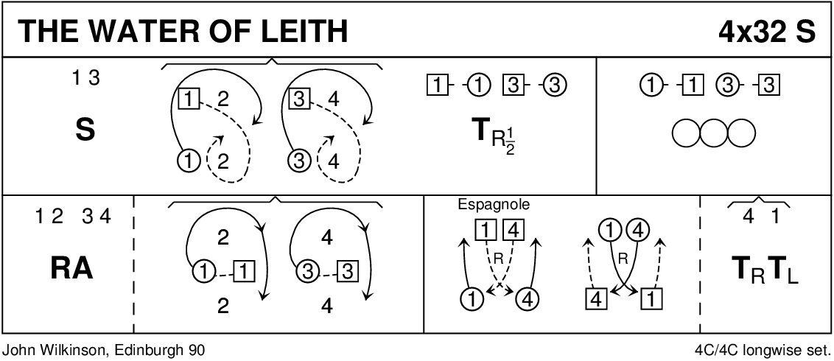
The Irish Rover
James B. Cosh 22 Scottish Country Dances (and 2 more) Music: The Irish Rover
Reel 8 x 32 bars 3 Couple Repeat 4 Couple Set Longwise Set
1-2 Taking nearer hands, 1s lead down below 3s;
3-4 1s cast up on own sides to 2nd place;
5-8 2s1L 1M3s right hands across;
9-12 1s half diagonal reel of 4 with first corners;
13-16 1s half diagonal reel of 4 with second corners, finishing by taking left hands;
17-24 1s turn about ¾ by the left into reels of 3 across, 1L with 2s, 1M with 3s, starting with left shoulder to first corner positions and finishing 1s in 2nd place on own sides, 3s at the top on opposite sides, 2s at the bottom on opposite sides;
25-28 3L1s2M half diagonal rights and lefts;
29-32 3M1s2L half diagonal rights and lefts, finishing 2s1s3s.
NB 12-13 In the original instructions, 1s pass left shoulders but the popular, right shoulder, form is quite commonly found
16-17 1s take left hands as they approach to finish the half diagonal reel of 4 and turn by the left appropriately to enter the reels of 3.
23-24 1s must hold back to finish their reels of 3 in 2nd place on own sides.

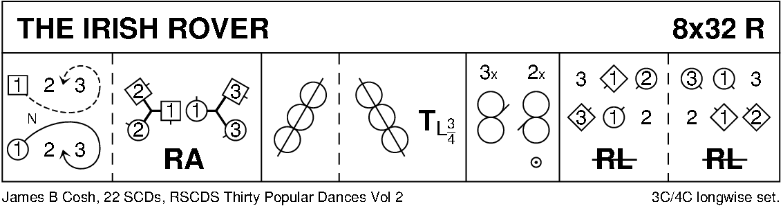

Ian Powrie's Farewell to Auchterarder (Music: original)
Bill Hamilton
Jig 128 bars 4 Couple Repeat 4 Couple Set Square Set
1-32 Ladies' Chorus:
1-8 All 8 hands round and back;
9-12 Ls dance in front of partner, behind next M and meet in centre;
13-16 Ls right hands across;
17-20 Ls dance in front of M standing opposite partner, behind next M and meet in centre;
21-24 Ls right hands across;
25-32 all promenade clockwise around the set to places.
33-64 1s and 3s solo:
33-36 1s release hold and, 1M leading, chase clockwise behind 2L, 1L dancing between 2s, 1M dancing around 2M, (finishing 1L facing 2L, 1M facing 2M) WHILE 3s dance likewise around 4s (finishing 3L facing 4L, 3M facing 4M);
37-40 1L2L 1M2M 3L4L 3M4M set and turn by the right, finishing with 2s 4s still in original places;
41-48 2L1L3M4M 2M1M3L4L reels of 4 across the dance, finishing with 2s 4s back in original places;
49-56 1s cross between 2s to start figures of 8 WHILE 3s cross between 4s to start figures of 8;
57-60 1s3s left hands across;
61-64 1L dance out between 2s and cast anticlockwise to place WHILE 1M dance out around 2M and cast anticlockwise to place WHILE 3L dance out between 4s and cast anticlockwise to place WHILE 3M dance out around 4M and cast anticlockwise to place.
65-96 2s and 4s solo:
Repeat the 1s and 3s solo with 2s dancing as 1s, 3s as 2s, 4s as 3s and 1s as 4s.
97-128 Men's Chorus:
97-104 All promenade anticlockwise around the set to places;
105-108 Mn dance in front of partner, behind next L and meet in centre;
109-112 Mn left hands across;
113-116 Mn dance in front of L standing opposite partner, behind next L and meet in centre;
117-120 Mn left hands across;
121-124 all 8 hands round to the right;
125-128 all 8 hands round to the left.

Dance Notes
33- 1L 3L follow partners.
-36 1s 3s must be on the inside facing out.
-40 1s 3s must be in same place as on bar 36.
41-48 cover in the reels;
63-64 1M 3M follow partners clockwise back to original places.
65- 1s 4s don't try to take promenade hold; Ls follow partners.
95-96 2L 4L must slow down to allow partners to catch up to take promenade hold for the Chorus.
125-128 It's more fun to continue with 8 hands round to the right again and to finish with a "hooch".

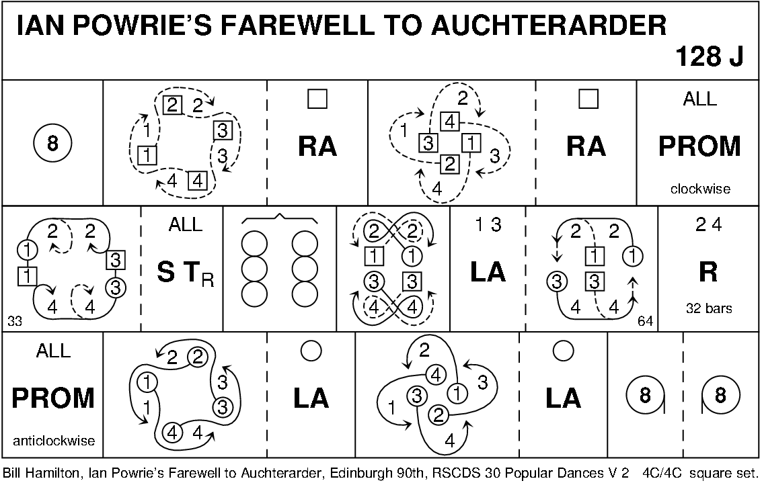
Cherrybank Gardens
John Drewry Bankhead Book (Music: Miss Eleanor)
Strathspey 3 x 32 bars 3 Couple Repeat 3 Couple Set Longwise Set
1-2 1s2s set on the sides;
3-4 1M 1L 2L 2M petronella turn one place anticlockwise, finishing Mn facing up, Ls down;
5-6 1s2s set facing up and down;
7-8 1L 2L 1M 2M petronella turn one place anticlockwise, finishing on opposite sides, 1s in 2nd place;
9-10 2s1s set on the sides;
11-12 2s cross by the right WHILE 1s turn ¾ by the left;
13-16 2s1L 1M3s right hands across;
17-20 1s3s set and link for 2 on the sides:
17-18 1s3s set on the sides;
19-20 1M dance down to 3M's place WHILE 3M cast up WHILE 1L cast WHILE 3L dance up to 2L's place;
21-24 3s1s 4 hands round to the left, finishing on the sides, 3s facing down, 1s up;
25-32 2s3s1s grand chain.

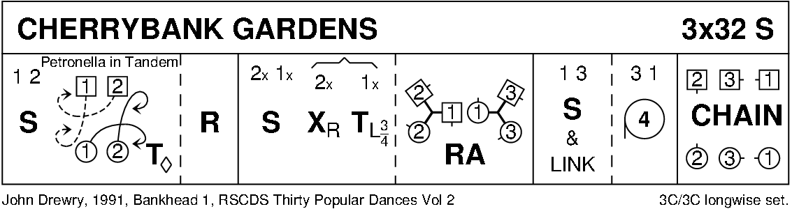
Napier's Index
Brian Charlton RSCDS Book 45 (Music: Bannockburn 700)
Jig 8 x 40 bars 3 Couple Repeat 4 Couple Set Longwise Set
1-4 1s set and cast;
5-8 1s turn 1¼ by the left, retain hold and take right hands with first corners;
9-10 1s balance in line with first corners;
11-14 1s turn first corners by the right;
15-16 repeat bars 9-10;
17-24 reels of three on the sides, 1s giving left shoulder to second corners to start, finishing in balance position with second corners;
25-32 1s repeat bars 9-16 with second corners;
33-38 reels of three across, 1s giving left shoulder to partner's first corners to start;
39-40 1s cross by the right to 2nd place.

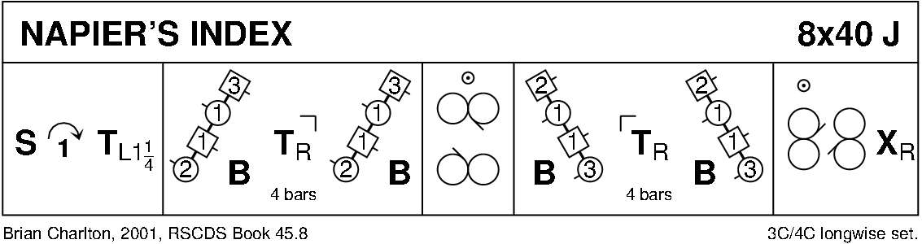
Peat Fire Flame
John Drewry Bon Accord Book Music: Original
Reel 8 x 40 bars 3 Couple Repeat 4 Couple Set Longwise Set
1-2 1s cast;
3-6 1s half figures of 8 round 2s;
7-8 1s turn by the left;
9-12 1s turn first corners by the right and pass by the right;
13-16 1s turn second corners by the left;
17-20 1s half diagonal reel of 4 with first corners;
21-24 1s half diagonal reel of 4 with second corners;
25-26 1s set to first corners (in partner's first corner position);
27-28 1s dance round clockwise back-to-back to face second corners (in partner's second corner position);
29-30 1s set to second corners;
31-32 1s dance round back-to-back finishing facing out on opposite sides;
33-36 3s2s half rights and lefts WHILE 1L cast up to finish facing down between 2s WHILE 1M cast down to finish facing up between 3s;
37-40 1s turn by the right 1¼ times WHILE 2s 3s turn by the right, finishing 2s1s3s.

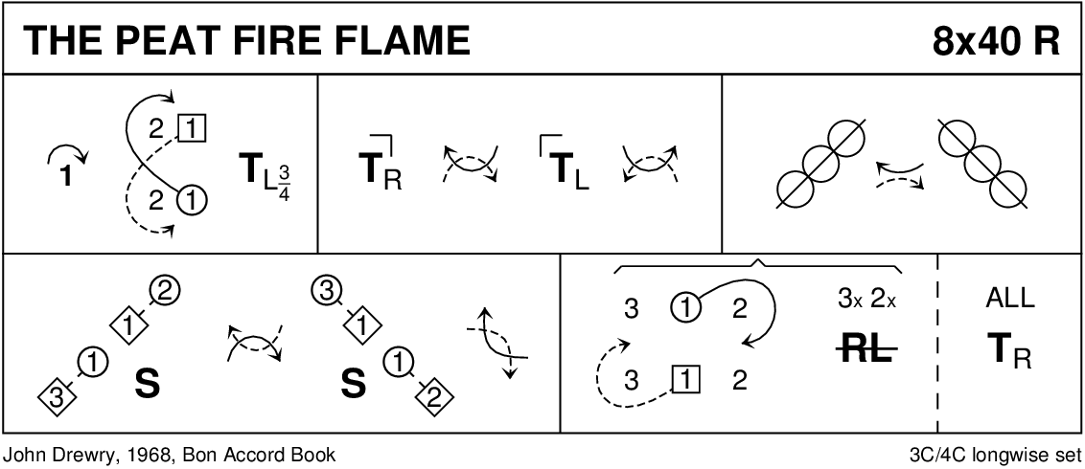
Duke of Perth
Reel 8 x 32 bars 3 Couple Repeat 4 Couple Set Longwise Set
1-4 1s turn by the right and cast;
5-8 1s turn by the left, finishing facing first corners;
9-16 1s turn corner, partner, corner, partner;
17-20 1s set to first corners and turn both hands;
21-24 1s set to second corners and turn both hands;
25-30 2s1s3s reels of 3 on sides (left shoulder to first corners to start);
31-32 1s cross to own sides, finishing 2s1s3s.
